CDN – Content Delivery Network

**What is a CDN**

A content delivery network (CDN) is a distributed network of servers that can efficiently deliver web content to users. A CDN store cached content on edge servers in point-of-presence (POP) locations that are close to end users, to minimize latency.

Azure CDN offers developers a global solution for rapidly delivering high-bandwidth content to users by caching their content at strategically placed physical nodes across the world. Azure CDN can also accelerate dynamic content, which can't get cached, by using various network optimizations using CDN POPs. For example, route optimization to bypass Border Gateway Protocol (BGP).

The benefits of using Azure CDN to deliver web site assets include:

* Better performance and improved user experience for end users, especially when using applications where multiple round-trips requests required by end users to load contents.
* Large scaling to better handle instantaneous high loads, such as the start of a product launch event.
* Distribution of user requests and serving of content directly from edge servers so that less traffic gets sent to the origin server.

For a list of current CDN node locations, see [Azure CDN POP locations](https://learn.microsoft.com/en-us/azure/cdn/cdn-pop-locations).

How it works

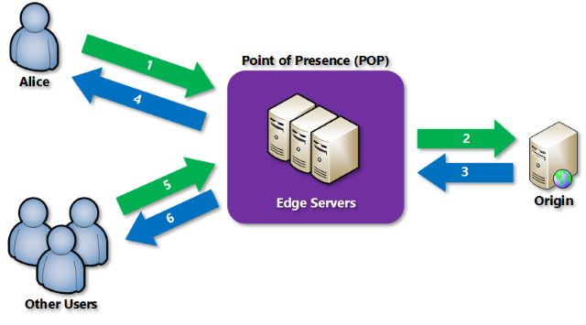

1. A user (Alice) requests a file (also called an asset) by using a URL with a special domain name, such as *<endpoint name>*.azureedge.net. This name can be an endpoint hostname or a custom domain. The DNS routes the request to the best performing POP location, which is usually the POP that is geographically closest to the user.
2. If no edge servers in the POP have the file in their cache, the POP requests the file from the origin server. The origin server can be an Azure Web App, Azure Cloud Service, Azure Storage account, or any publicly accessible web server.
3. The origin server returns the file to an edge server in the POP.
4. An edge server in the POP caches the file and returns the file to the original requestor (Alice). The file remains cached on the edge server in the POP until the time-to-live (TTL) specified by its HTTP headers expires. If the origin server didn't specify a TTL, the default TTL is seven days.
5. More users can then request the same file by using the same URL that Alice used, and gets directed to the same POP.
6. If the TTL for the file hasn't expired, the POP edge server returns the file directly from the cache. This process results in a faster, more responsive user experience.

Requirements

* To use Azure CDN, you must own at least one Azure subscription.
* You also need to create a CDN profile, which is a collection of CDN endpoints. Every CDN endpoint is a specific configuration which users can customize with required content delivery behavior and access. To organize your CDN endpoints by internet domain, web application, or some other criteria, you can use multiple profiles.
* Since [Azure CDN pricing](https://azure.microsoft.com/pricing/details/cdn/) gets applied at the CDN profile level, so if you want to use a mix of pricing tiers you must create multiple CDN profiles. For information about the Azure CDN billing structure, see [Understanding Azure CDN billing](https://learn.microsoft.com/en-us/azure/cdn/cdn-billing).

Limitations

Each Azure subscription has default limits for the following resources:

* The number of CDN profiles created.
* The number of endpoints created in a CDN profile.
* The number of custom domains mapped to an endpoint.

For more information about CDN subscription limits, see [CDN limits](https://learn.microsoft.com/en-us/azure/azure-resource-manager/management/azure-subscription-service-limits).

Azure CDN features

Azure CDN offers the following key features:

* [Dynamic site acceleration](https://learn.microsoft.com/en-us/azure/cdn/cdn-dynamic-site-acceleration)
* [CDN caching rules](https://learn.microsoft.com/en-us/azure/cdn/cdn-caching-rules)
* [HTTPS custom domain support](https://learn.microsoft.com/en-us/azure/cdn/cdn-custom-ssl)
* [Azure diagnostics logs](https://learn.microsoft.com/en-us/azure/cdn/cdn-azure-diagnostic-logs)
* [File compression](https://learn.microsoft.com/en-us/azure/cdn/cdn-improve-performance)
* [Geo-filtering](https://learn.microsoft.com/en-us/azure/cdn/cdn-restrict-access-by-country-region)